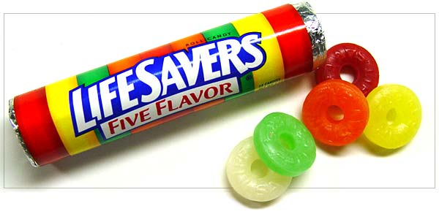 | LifeSaver  Award  Program

Complete the form below and send it to:

lifesaver@communitasma.org or to Communitas Lifesaver
60-D Audubon Road
Wakefield, MA 01880

What is your name?

Who do you want to nominate?

Describe how are they affiliated with Communitas?
(ex: staff, volunteer, individual, family, vendor, service partner, committee member, etc.)

What program are they primarily affiliated with?
(ex: Day Hab, Career Service, Residential, Family Resources, Recreation, etc)

In the space below, please describe why you feel this person is a LifeSaver:

Also, please write one sentence to describe this person:

S:\Blank Forms\LifeSaver Nomination Form.doc

