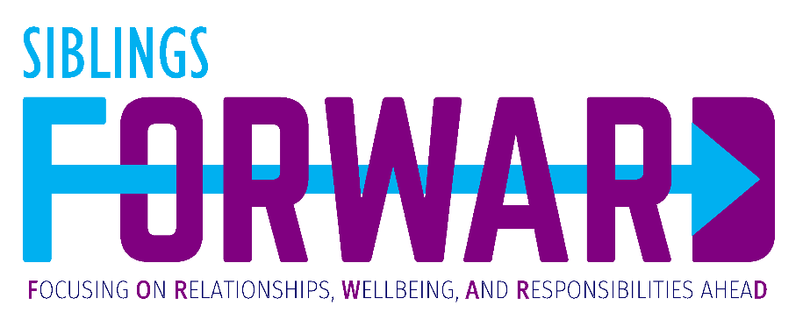
Researchers at Boston University are looking for adult siblings with a family member on the autism spectrum to provide feedback about a new program. The Siblings FORWARD program was designed to help siblings work with their family to plan for the future. One group of siblings will participate in 6 or 7 virtual meetings where they will work with a facilitator to identify and work toward individual future planning goals. The other group of siblings will receive online educational materials about adult autism services to review independently.
If you are interested in hearing more about the study,
please fill out the form below.

By filling out this form, I agree to let a member of the research team at Boston University contact me with more information about the study.

Name: ___________________________ Email Address: _______________________________
Phone Number: ____________________ Alternate Phone Number:_______________________
Preferred method of communication: ______________________________________________________
______________________________________________________________________________________

Please return completed forms via email to forward@bu.edu or via fax at 617-353-9609
If you have questions, please contact:

Kristin A. Long, PhD Marcella Mazzenga
Assistant Professor Lab Manager, Child & Family Health Lab
Dept. of Psychological & Brain Sciences Boston University
Boston University forward@bu.edu
KALong@bu.edu 617-358-1633
(617) 358-4296

